Title: | Window Lifter  Window Lifter Module Design

History
Issue status  (Index) | Maturity/Date  (draft/invalid/valid)  (dd-mmm-yyyy) | Author  AEP CES | Check/Release  AEP CES | Description
1.0 | Draft  04-0ct-09 | Alexis Garcia | Alexis Garcia | Creation of the document

Table of Contents
1 Purpose 3
2 Definitions and abbreviations 3
3 Realization constraints and targets 3
4 SW Conceptual design 3
5 SW Component internal breakdown 4
5.1 Functional Decomposition 4
5.2 Function <Type> <function name> (type par 1, .., type par n) 5
5.3 Function <Type> <function name> (type par 1, .., type par n) 5

Purpose
The purpose of this document is to specify the function of the module of the window lifter and the relation between his components. This includes the function of UP and DOWN with a validation of the button press, also a pinch function for the safety of the user and prevention of accidents.

Definitions and abbreviations
Definitions
PIT | Process interrupt timer
GPIO | General Purpose Input Output
STM | System Timer Module
MCcore | Microcontroller core
onetouch | Function for the automatic mode
Anti pinch | Feature that prevents accidents while the window goes up

Abbreviations
References
N° | Document name | Reference
1 | Window Lifter Requirements
2 | Traceability Matrix WL Module

Realization constraints and targets

The main purpose of this module is to provide the capability to the final user to be able to control the movement of the window in up and down direction; also this module provides a function of anti pinch, which downs the window in case of emergency of a possible accident. For a valid button press, it must last at least 10 ms, the auto mode is active if the press last for less than 500 otherwise the manual function is active while the button is press, the transition between each step of the window is 400 ms. The anti pinch feature it can only be activated in the up movement, downs totally the window and blocks the buttons for 5 seconds.

SW Conceptual design
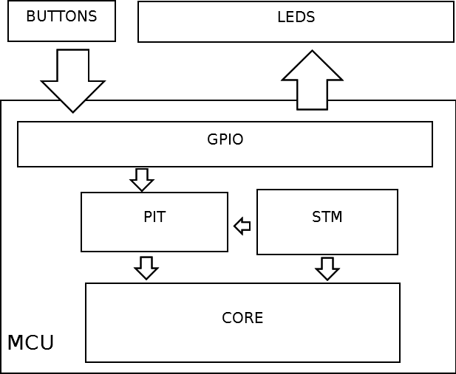

SW Component internal breakdown

Functional Decomposition
Overview of functions and their dependencies shown by a Static Function Tree
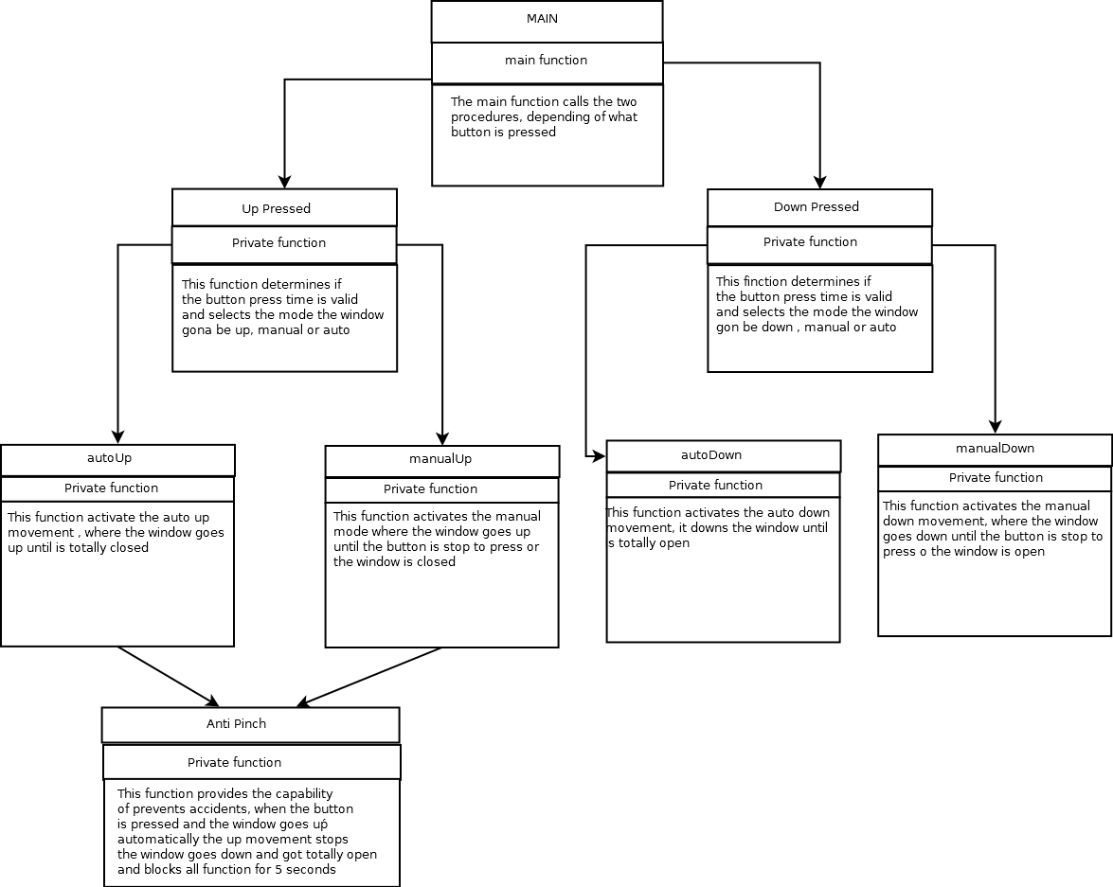
Function Description and Dynamic Behavior

Function void initGPIO (void)

Description | Configures and set the inputs and outputs from the port A to
Return Value | Void
Precondition | This is called only in the configuration before the infinite loop

Function void initTimer (void)
Description | Configuration and initialization of the SMT module
Return Value | Void
Precondition | This is called only in the configuration before the infinite loop

Function void delay (T_UWORD luw_time)
Description | Provides a delay of the value sent in the variable luw_time in miliseconds
Parameter 1  <input| output| inout> | luw_time  input
Return Value | Void
Precondition | This is called each time a delay is needed

Function void initLeds (void)
Description | Sets all the leds , red leds in on, blue and green leds in off, for demonstration and reset purpose
Return Value | Void
Precondition | This is called only in the configuration before the infinite loop

Function void downPressed (void)
Description | Called when the down button is pressed. Counts the time in ms and valids , if the time pressed is valid , selects manual or automatic mode and calls the respective function
Return Value | Void
Precondition | This is called on the infinite loop each time the down button is pressed

Function void autoDown (void)
Description | This function provides the functionality of automatic down , where all actual turn on leds go off in sequence
Return Value | Void
Precondition | This is called only in the autopinch and the downPressed functions

Function void manualDown (T_UBYTE *ptr)
Description | This function provides the functionality of the manual down, where from the actual led on , starts to turn off the leds until the button is ceased to press
Parameter 1  <input| output| inout> | lpub_ptr  input
Return Value | Void
Precondition | This is called only in the donwpressed function

Function void upPressed (void)
Description | Called when the down button is pressed. Counts the time in ms and valids , if the time pressed is valid , selects manual or automatic mode and calls the respective function
Return Value | Void
Precondition | This function is called on the infinite loop each time the up button is pressed

Function void autoUp (void)
Description | This function provides the functionality of automatic up, where all actual turn off leds go on in sequence
Return Value | void
Precondition | This is called only in the upPressed function

Function void manualUp (T_UBYTE *lpub_ptr)
Description | This function provides the functionality of the manual up, where from the actual led off , starts to turn on the leds until the button is ceased to press
Parameter 1  <input| output| inout> | lpub_ptr  input
Return Value | Void
Precondition | This is called only in the upPressed function

Function void pinchInterruption (void)
Description | This function provides a handling for the interruption in the case the autopinch button is pressed
Return Value | Void
Precondition | This is called only in the case of the goUp flag is true (activates only in the manual up and autoup functions)

Flow chart for functions

upPressed
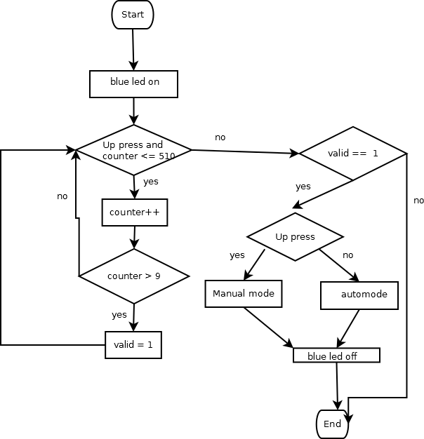

downPress
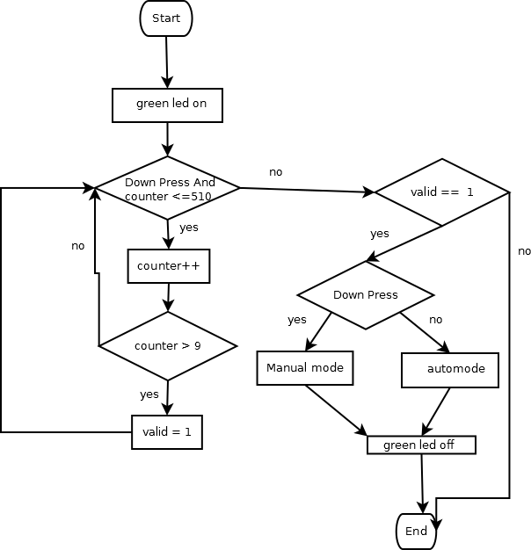

autoUp
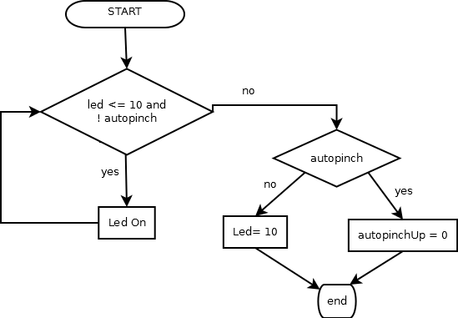
autoDown
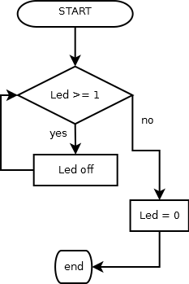

manualUp
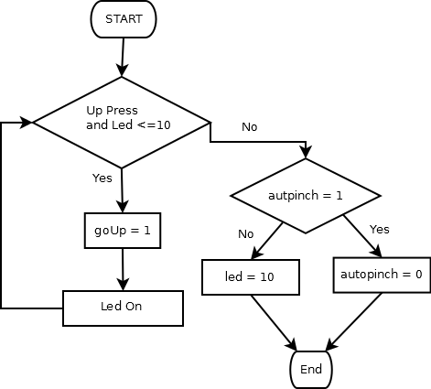
manualDown
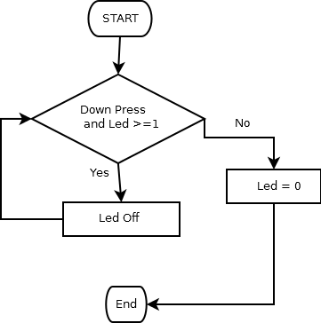

pinchInterruption
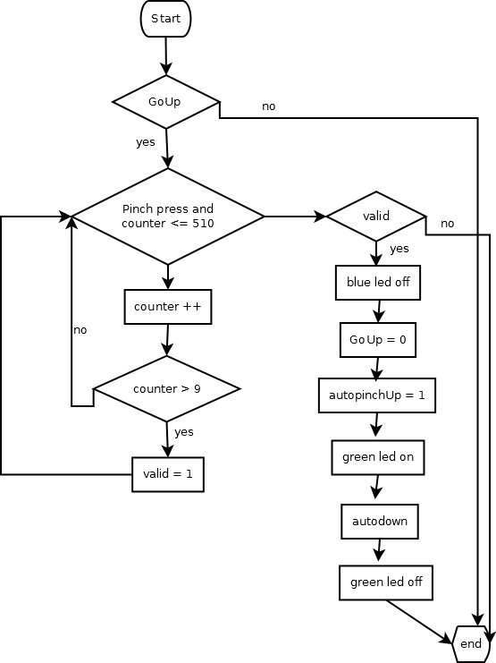

Dynamic Behavior
State Chart¹, Flow Chart¹, Nassi Shneiderman
¹ Preferred
